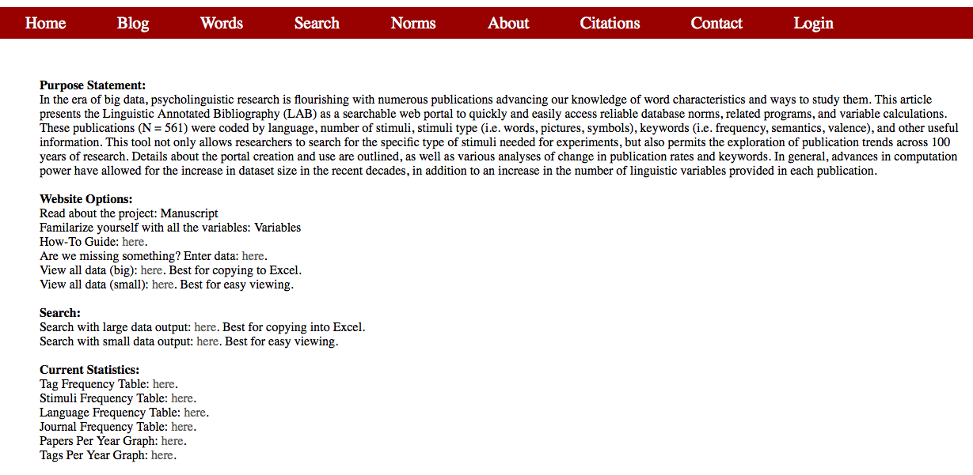

*Figure 1.* The layout of the LAB web portal, which can be found by clicking on the Norms link in the menu bar.

*Figure 2.* Number of publications plotted in half decade intervals.

|  |  |
| --- | --- |
|  |  |
|  |  |

*Figure 3*. Scatterplots of number of stimuli by year. The top left quadrant shows all years and stimuli, the top right quadrant shows stimuli numbers in the 0 to 1000 range, and the bottom two quadrants show 1,000 – 500,000, and 500,000+ numbers of stimuli across years.

*Figure 4.* Average number of tags per publication plotted in half decade intervals.